Select All
Easy
Basic Select
Query all columns (attributes) for every row in the CITY table.
The CITY table is described as follows:
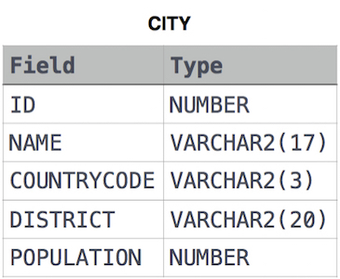
Query:-
SELECT *
FROM CITY;

Congratulations!
You have passed the sample test cases. Click the submit button to run your code against all the test cases.
Sample Test case 0

Your Output (stdout)
- 6 Rotterdam NLD Zuid-Holland 593321
- 3878 Scottsdale USA Arizona 202705
- 3965 Corona USA California 124966
- 3973 Concord USA California 121780
- 3977 Cedar Rapids USA Iowa 120758
- 3982 Coral Springs USA Florida 117549
- 4054 Fairfield USA California 92256
- 4058 Boulder USA Colorado 91238
- 4061 Fall River USA Massachusetts 90555

Expected Output
- 6 Rotterdam NLD Zuid-Holland 593321
- 3878 Scottsdale USA Arizona 202705
- 3965 Corona USA California 124966
- 3973 Concord USA California 121780
- 3977 Cedar Rapids USA Iowa 120758
- 3982 Coral Springs USA Florida 117549
- 4054 Fairfield USA California 92256
- 4058 Boulder USA Colorado 91238
- 4061 Fall River USA Massachusetts 90555

